Quiz 02
( 01 )
Actors student, examiner
Use cases login, view available exams, submit answers, create exams, view student score

( 02 )
Student
Log in
View available exams
Attempt exams
Submit answers
Examiner
Create exams
View student score

Quiz 03

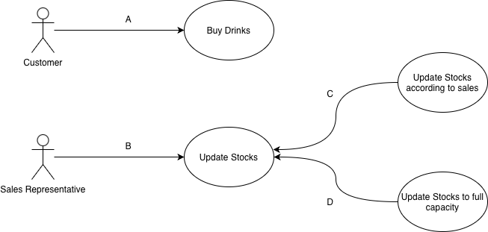
A – association B – association C – exclude D – exclude
Quiz 04
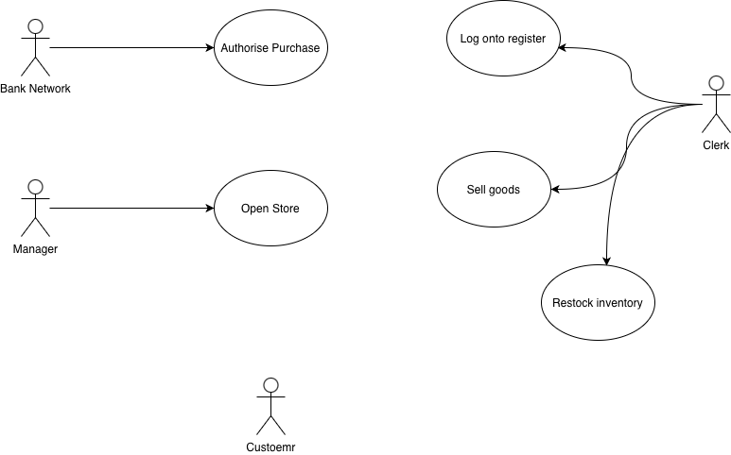
Clerk, manager, bank network
(customer has nothing to do)

